EDS - Assignment No.1

**Name: Kalyani Pardeshi**

**RollNo**.750 **Batch:-G3**

**Problem statement:-** Take/Prepare any text files for any real-lifeapplication. For Ex. “Stud.txt”, “Placement.csv” and “Result. csv” files forresult Analysis. Combine into “StudentDetails.csv”. Perform all statisticalanalysis(Average,Max, Min,Count, Sum, Percentage)onit.

# CSVfiles:-

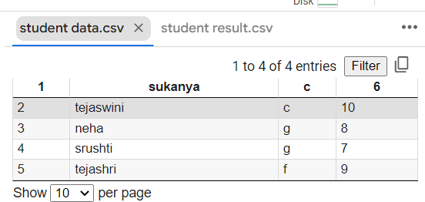**/content/studentdata.csv**

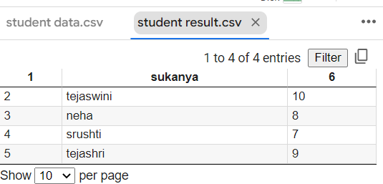**/content/studentresult.csv**

# Programme:-

importcsv

deftop_5_std(d3):

d3.sort(key= lambda x: int(x[3]),reverse=True)print("sorteddata:",d3)

print("\n\nTop1 student",d3[0][1])print("\n\nTop2 student",d3[1][1])print("\n\nTop3 student",d3[2][1])print("\n\nTop4 student",d3[3][1])print("\n\nTop5student",d3[4][1])

f1= open("student data.csv","r")f2=open("studentresult.csv","r")

f3=open("studentdata_studentresult.csv","w")

d1=list(csv.reader(f1,delimiter=','))d2=list(csv.reader(f2,delimiter=','))

print("\n\nFile1 contents:",d1)print("\n\nFile2 Contents:",d2)d3=[]

for i in range(len(d1)):d3.append(d1[i]+d2[i])

print(d3)

cw=csv.writer(f3)cw.writerows(d3)

top_5_std(d3)

f1.close()f2.close()f3.close()

sgpa=[]

withopen("/content/studentdata_studentresult.csv",mode='r')asfile:

csvfile=csv.reader(file)

for lines in csvfile:sgpa.append(int(lines[3]))print("maximumsgpa",max(sgpa))print("minimumsgpa",min(sgpa))print("sumofsgpa",sum(sgpa))

print("averagesgpa",sum(sgpa)/len(sgpa))

# Output:-

File1contents:[['1','sukanya','c','6'],['2','tejaswini','c','10'],['3','neha','g','8'],

['4','srushti','g','7'],['5','tejashri','f','9']]

File2Contents:[['1','sukanya','6'],['2','tejaswini','10'],['3','neha','8'],['4',

'srushti','7'],['5','tejashri','9']]

[['1','sukanya','c','6','1','sukanya','6'],['2','tejaswini','c','10','2','tejaswini','10'],

['3','neha','g','8','3','neha','8'],['4','srushti','g','7','4','srushti','7'],['5','tejashri',

'f','9','5','tejashri','9']]

sorteddata:[['2','tejaswini','c','10','2','tejaswini','10'],['5','tejashri','f','9','5',

'tejashri','9'],['3','neha','g','8','3','neha','8'],['4','srushti','g','7','4','srushti','7'],

['1','sukanya','c','6','1','sukanya','6']]Top1 studenttejaswini

Top2studenttejashriTop3 student nehaTop4studentsrushti

Top5studentsukanya

maximumsgpa 10

minimumsgpa6sum of sgpa 40averagesgpa8.0